My bedroom
Hello.
My name´s ___________ and this is my bedroom.
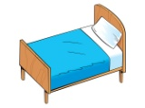
My favourite colour´s _______________.
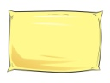
_________________ __________ ______________.
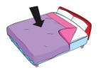
_________________ my _____________________.
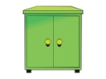
_________________ my _____________________.
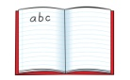
_________________ ___________ _______________.
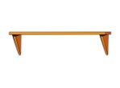
_________________ ___________ _______________.
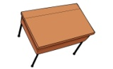
_________________ my _____________________.
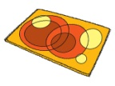
_________________ __________ ______________.
I´ve got / I haven´t got a _________________________.
I like ________________________________________________.
Bye!
From __________________________

